**Design Pattern – 2**

**Factory**

The purpose is to hide the creation of instances. With this pattern, the code does not depend on concrete classes. A specific class can now be replaced with no impact in the client code.

**Code Snippet:**

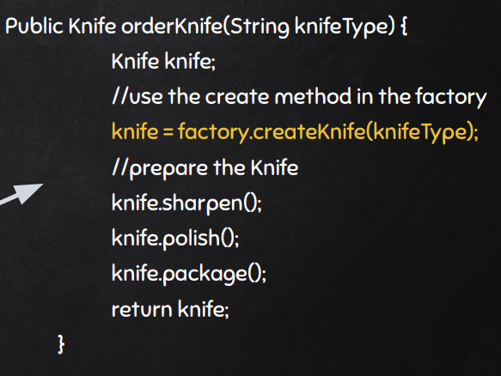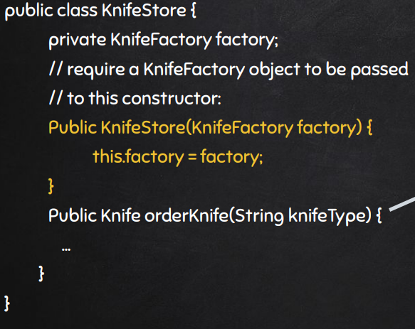

**Code Location:**

The classes are in the folloying path:

“*src-gen\main\java\org\jabref\logic\importer\fileformat\medline\ObjectFactory*”

A lot of *QName*’s are created, with diferent *localPart*’s:

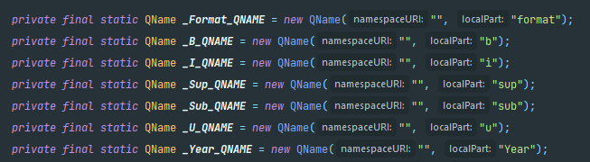

Different *QName*’s are used to create diferent *JAXBElement<Text>*’s:

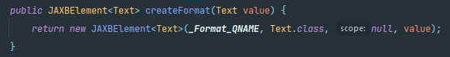

**Justification:**

As we can see in the images, the class *ObjectFactory* is used to hide the creation of *JAXElement<Text>* classes. In the first image, we create all the *QName’s* we need. Then, we use it create all kinds of  *JAXElement< Text>.*